**ARDUINO COMPLETED**

Follow the schematics to the complete connections. And not fully my knowledge and I was assisted by Daniel Iheanacho and Davis-Eke Dubem.

**Note**:Connect the positive pin(long Pin) of the LED in series with a 330 Ohm resistor then other to ground.

1. **Traffic Light Project**

Traffic light project simulation of real life traffic and pedestrians crossing. The proximity sensor senses the presence of a pedestrian and gives them an opportunity based on time to cross within a green light state.

**THE NEEDED APPARATUS ARE:**

* **ARDUINO UNO**
* **BUZZER**
* **I.R. PROXIMITY SENSOR**
* **YELLOW, RED AND GREEN LEDS**
* **JUMPER WIRES**
* **330 OHMS RESISTORS X4**
* **BREADBOARD**

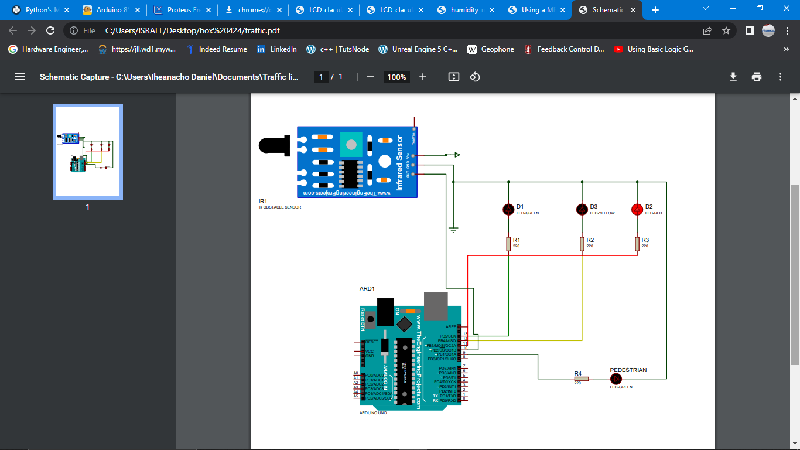

**BELOW ARE THE REQUIRED PROCEDURES**

1. Create a ground and 5 volts reel on the breadboard from the Arduino, so all connections to the ground or 5 volts reel is still directly connected to the Arduino.
2. **Connecting proximity sensor to Arduino**

* Connect the ground pin of the proximity sensor to the Arduino ground pin
* Connect the Vcc pin of the proximity sensor to the Arduino 5v Pin
* Connect the Out pin of the Proximity sensor to the Arduino Pin on the schematic

1. **Connecting LEDS to Arduino**

* Connect the ground pin(short Pin) of the LED to the Arduino ground Pin
* Connect the positive pin(long Pin) of the LED in series with a 330 Ohm resistor then to the Arduino Pins repectively.
* Connect the pins of the LEDS to the Arduino pin from the other end of the resistor.
* Upload the code below

**CODE**



1. **Alarm Project using time module**

A simulation of real life alarm clock. Using the real time clock module as a time source which is reliable with a long life lasting C-mos battery.

**THE NEEDED APPARATUS ARE:**

* **ARDUINO UNO**
* **BUZZER**
* **R.T.C. (REAL TIME CLOCK MODULE)**
* **JUMPER WIRES**
* **BREADBOARD**

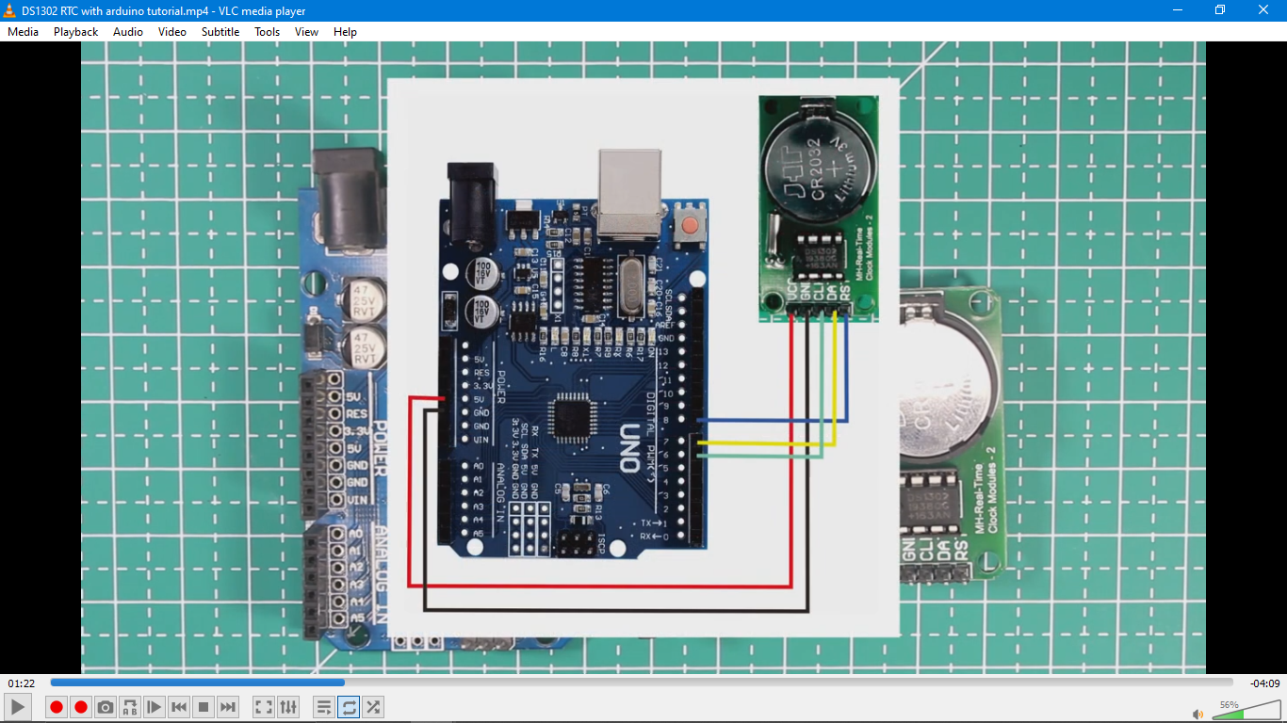

**BELOW ARE THE REQUIRED PROCEDURES**

A Ground is made and 5 volts reel on the breadboard from the Arduino, so all connections to the ground or 5volts reel is still directly connected to the Arduino.

1. **Connecting Buzzer to Arduino**

* Connect the short pin of the Buzzer to the ground of Arduino
* Connect the long Pin of the Buzzer to the assigned Arduino Pin

1. **Connecting the RTC(real time clock) module to the Arduino**

* Connect the ground pin of the RTC to the Arduino ground Pin
* Connect the Vcc pin of the RTC to the Arduino 5v or 3.3v Pin
* Connect the SCL, RST and SDA pins to the assigned Arduino Pin.
* Upload the below

**CODE**



1. **Distance Measuring using ultra-sonic sensor**

Using the ultra-sonic sensor based on when sent impulse was received to measure distance.

**THE NEEDED APPARATUS ARE:**

* **ARDUINO UNO**
* **ULTRA-SONIC SENSOR**
* **JUMPER WIRES**
* **BREADBOARD**

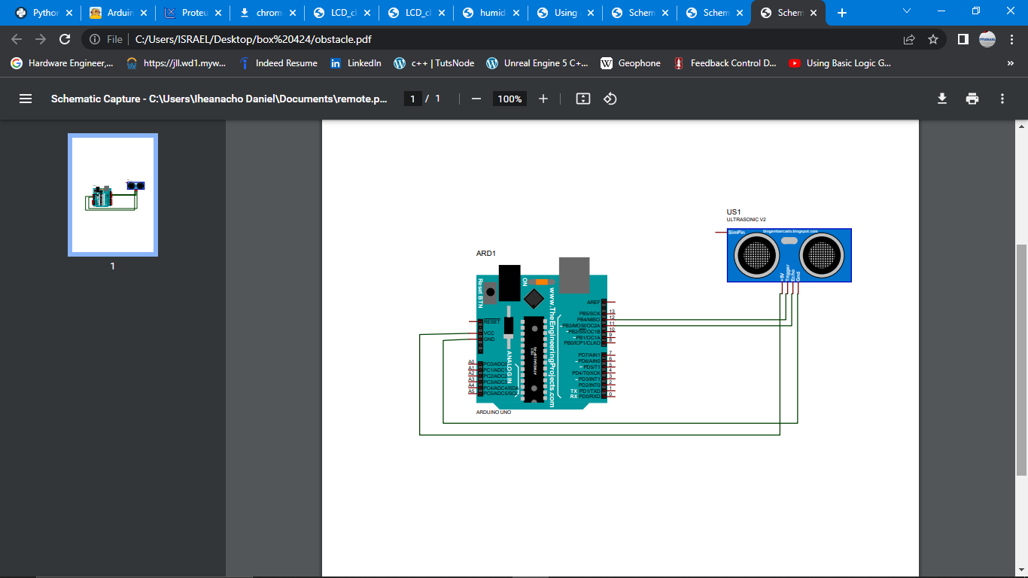

**BELOW ARE THE REQUIRED PROCEDURES**

Make a Ground and 5 volts reel on the breadboard from the Arduino, so all connections to the ground or 5volts reel is still directly connected to the Arduino.

1. **Connecting the ultra-sonic sensor to the Arduino**

* Connect the ground pin of the ultra-sonic sensor to the Arduino ground Pin
* Connect the Vcc pin of the ultra-sonic sensor to the Arduino 5v Pin
* Connect the tpin and epin pins to the assigned Arduino Pin.
* Upload the code below

**CODE**



1. **OBSTACLE DETECTION USING ULTRA-SONIC SENSOR**

Using the ultra-sonic sensor based on when sent impulse was received to measure distance then using the distance to detect how close an object is.

**THE NEEDED APPARATUS ARE:**

* **ARDUINO UNO**
* **ULTRA-SONIC SENSOR**
* **JUMPER WIRES**
* **BREADBOARD**



**BELOW ARE THE REQUIRED PROCEDURES**

Make a Ground and 5 volts reel on the breadboard from the Arduino, so all connections to the ground or 5volts reel is still directly connected to the Arduino.

1. **Connecting Buzzer to Arduino**

* Connect the short pin of the Buzzer to the ground of Arduino
* Connect the long Pin of the Buzzer to the assigned Arduino Pin

1. **Connecting the ultra-sonic sensor to the Arduino**

* Connect the ground pin of the ultra-sonic sensor to the Arduino ground Pin
* Connect the Vcc pin of the ultra-sonic sensor to the Arduino 5v Pin
* Connect the T pin and E pin pins to the assigned Arduino Pin.
* Upload the code below

**CODE**



1. **16*2 CALCULATOR**

Using the liquid crystal display to give output to be displayed to the user. Which can be timed or placed constant.

**THE NEEDED APPARATUS ARE:**

* **ARDUINO UNO**
* **LCD 16X2 DISPLAY**
* **JUMPER WIRES**
* **POTENTIOMETER**
* **BREADBOARD**

**BELOW ARE THE REQUIRED PROCEDURES**

make a Ground and 5 volts reel on the breadboard from the Arduino, so all connections to the ground or 5volts reel is still directly connected to the Arduino.

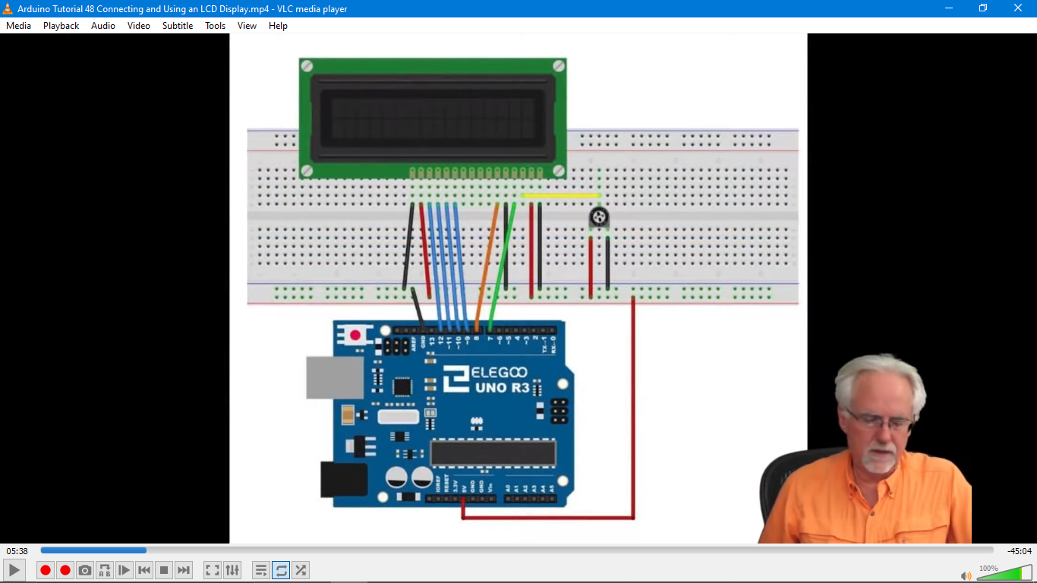

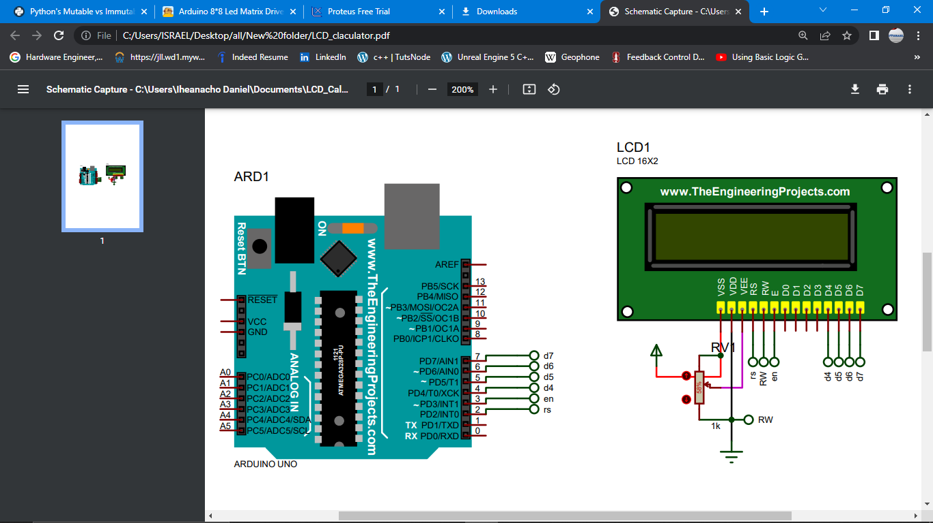

1. **Connecting the LCD to the Arduino**

* Connect the vdd of the ultra-sonic sensor to the Arduino ground Pin
* Connect the Vcc pin of the ultra-sonic sensor to the Arduino 5v Pin
* Connect the rs,en,d4,d5,d6,d7 pins to the assigned Arduino Pin.
* Connect Vee to potentiometer and potentiometer to ground and 5v according to the schematics
* Connect the blcka pin to ground and blckb pin to 5v.
* Upload the code below

**CODE**



1. **BIT COUNTER USING 74HC595 SHIFT REGISTER**

74HC595 shift register gives the ability to use one signal to send data to 8 output devices such as LED's.

**THE NEEDED APPARATUS ARE:**

* **ARDUINO UNO**
* **74HC595 SHIFT REGISTER**
* **LED'S**
* **330 OHMS RESISTORS**
* **JUMPER WIRES**
* **BREADBOARD**

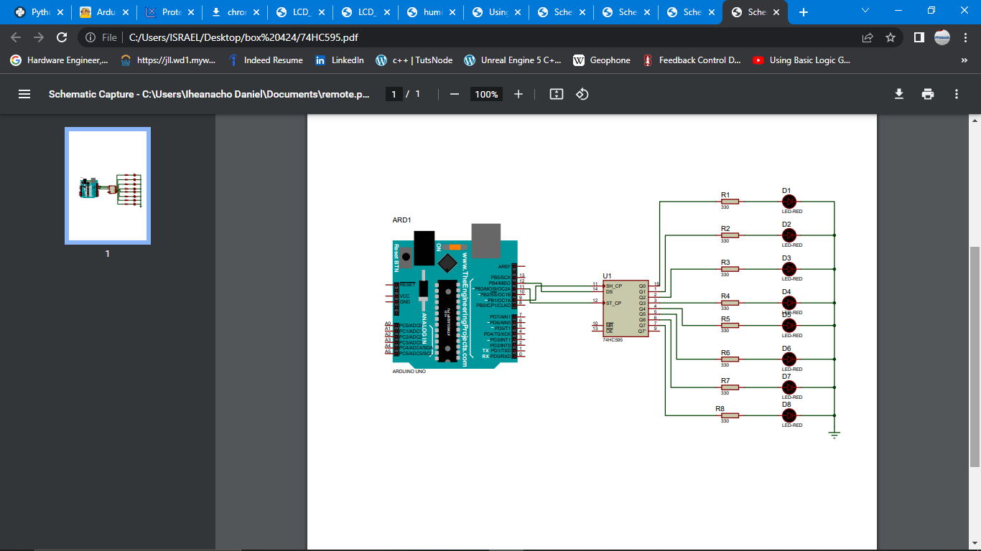

**BELOW ARE THE REQUIRED PROCEDURES**

make a Ground and 5 volts reel on the breadboard from the Arduino, so all connections to the ground or 5volts reel is still directly connected to the Arduino.

1. **Connecting the shift register to the Arduino**

* Connect the ground of the shift register to the Arduino ground Pin
* Connect the Vcc pin of the shift register to the Arduino 5v Pin
* Connect latchPin to pin 11
* Connect the clockPin to pin 9
* Connect the dataPin to pin 12

1. **Connecting LEDS to Arduino**

* Connect the ground pin(short Pin) of the LED to the Arduino ground Pin
* Connect the positive pin(long Pin) of the LED in series with a 330 Ohm resistor then to the Arduino Pins repectively.
* Connect the pins of the LEDS to the Arduino pin from the other end of the resistor.
* Upload code below



1. **MINI CHATTING SYSTEM USING BLUETOOTH MODULE**

Using the Bluetooth module HC-05 to interface between Arduino and a Bluetooth device(phone).

**THE NEEDED APPARATUS ARE:**

* **ARDUINO UNO**
* **HC-05 BLUETOOTH MODULE**
* **JUMPER WIRES**
* **BREADBOARD**

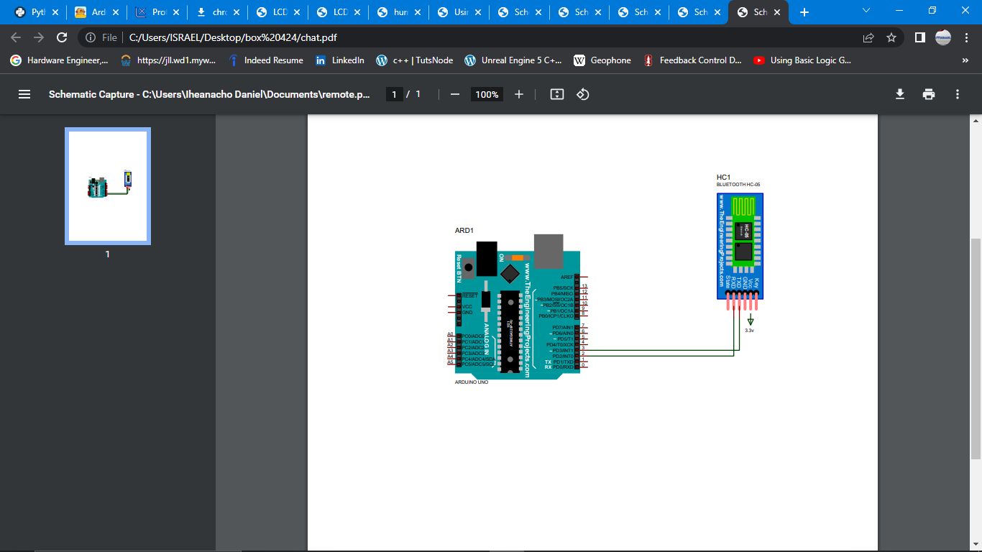

**BELOW ARE THE REQUIRED PROCEDURES**

make a Ground and 5 volts reel on the breadboard from the Arduino, so all connections to the ground or 5volts reel is still directly connected to the Arduino.

1. **Connecting the Bluetooth Module to the Arduino**

* Connect the ground of the shift register to the Arduino ground Pin
* Connect the Vcc pin of the shift register to the Arduino 3,3v Pin
* Connect TX pin 3
* Connect the Rx to pin 2

Upload the code below

**CODE**



1. **Remote controlled RGB LED**

Using remote to control RGB LED.

**THE NEEDED APPARATUS ARE:**

* **ARDUINO UNO**
* **RGB LED**
* **330 OHMS RESISTORS**
* **IR RECEIVER AND IR REMOTE**
* **JUMPER WIRES**
* **BREADBOARD**

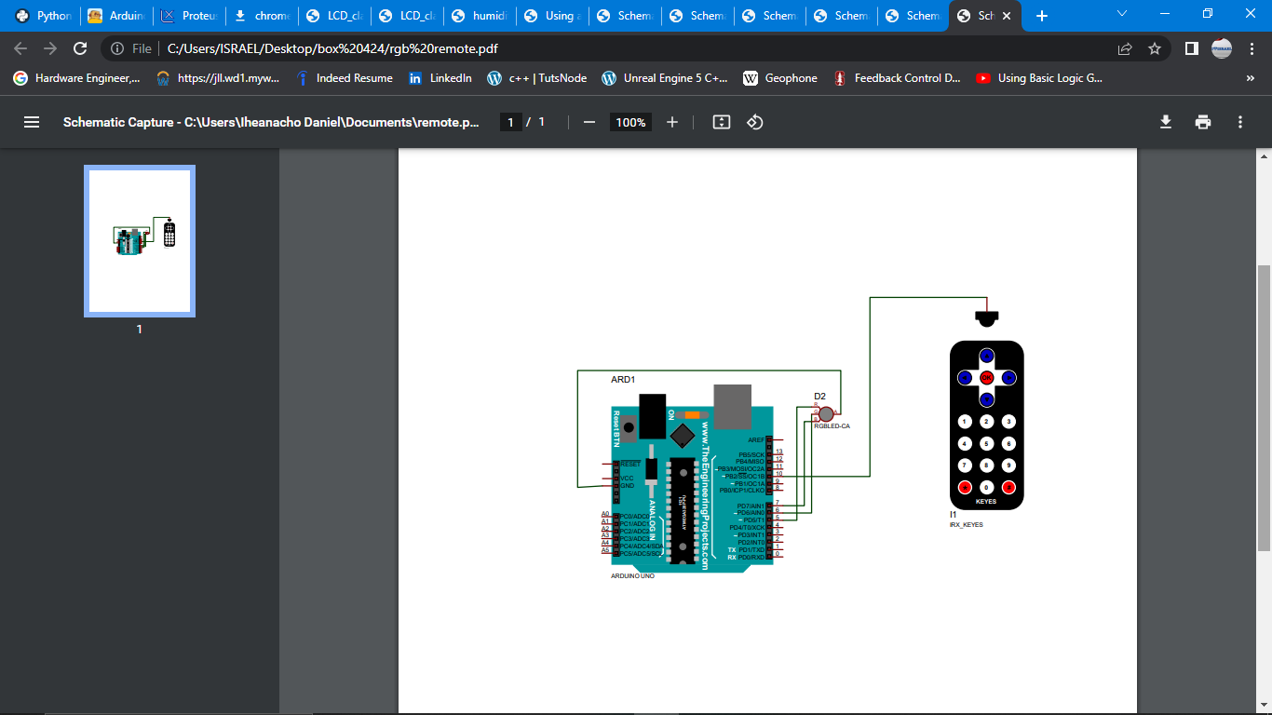

**BELOW ARE THE REQUIRED PROCEDURES**

make a Ground and 5 volts reel on the breadboard from the Arduino, so all connections to the ground or 5volts reel is still directly connected to the Arduino.

1. **Connecting the Ir receiver to the Arduino**

* Connect the ground of the shift register to the Arduino ground Pin
* Connect the VCC pin of the shift register to the Arduino 5v Pin
* Connect IR pin to pin 10

1. **Connecting LEDS to Arduino**

* Connect the ground pin(short Pin) of the LED to the Arduino ground Pin
* Connect the positive pin(long Pin) of the LED in series with a 330 Ohm resistor then to the Arduino Pins repectively.
* Connect the pins of the LEDS to the Arduino pin from the other end of the resistor.

Upload the code below

**CODE**



1. **REMOTE CONTROLLED DISCO LIGHTS**

Using remote to control RGB LED giving different color arrangement in random manner.

**THE NEEDED APPARATUS ARE:**

* **ARDUINO UNO**
* **RGB LED's**
* **330 OHMS RESISTORS**
* **IR RECEIVER AND IR REMOTE**
* **JUMPER WIRES**
* **BREADBOARD**

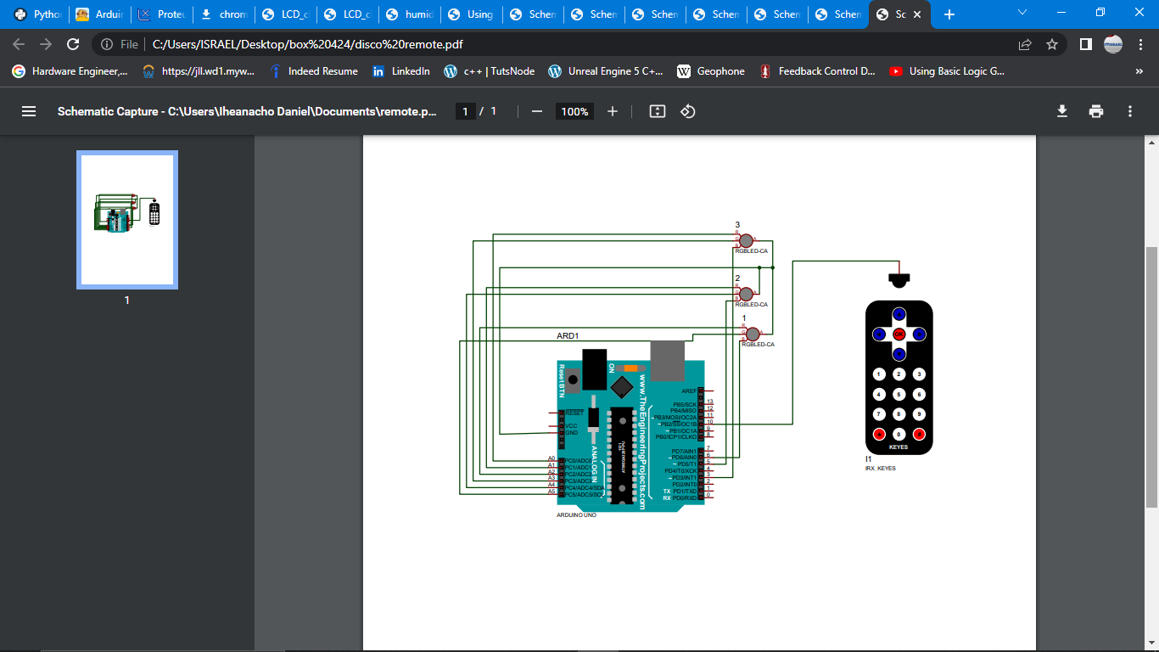

**BELOW ARE THE REQUIRED PROCEDURES**

Make a Ground and 5 volts reel on the breadboard from the Arduino, so all connections to the ground or 5volts reel is still directly connected to the Arduino.

1. **Connecting the Ir receiver to the Arduino**

* Connect the ground of the shift register to the Arduino ground Pin
* Connect the Vcc pin of the shift register to the Arduino 5v Pin
* Connect IR pin to pin 10

1. **Connecting LEDS to Arduino**

* Connect the ground pin(short Pin) of the LED to the Arduino ground Pin
* Connect the positive pin(long Pin) of the LED in series with a 330 Ohm resistor then to the Arduino Pins repectively.
* Connect the pins of the LEDS to the Arduino pin from the other end of the resistor.

Upload the code below

**CODE**



1. **USING POTENTIOMETER TO CONTROL LEDS BRIGHTNESS**

Using potentiometer to control led brightness.

**THE NEEDED APPARATUS ARE:**

* **ARDUINO UNO**
* **LED**
* **330 OHMS RESISTORS**
* **Potentiometer**
* **JUMPER WIRES**
* **BREADBOARD**

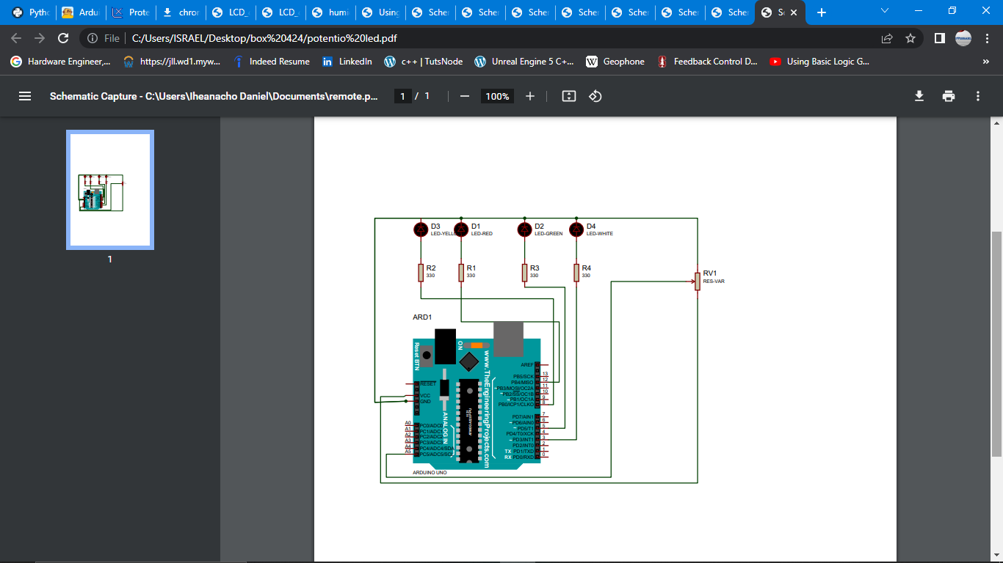

**BELOW ARE THE REQUIRED PROCEDURES**

make a Ground and 5 volts reel on the breadboard from the Arduino, so all connections to the ground or 5volts reel is still directly connected to the Arduino.

1. **Connecting the Potentiometer to the Arduino**

* Connect the ground of the shift register to the potentiometer ground Pin
* Connect the Vcc pin of the shift register to the potentiometer 5v Pin
* Connect output pin to assigned pin

1. **Connecting LEDS to Arduino**

* Connect the ground pin(short Pin) of the LED to the Arduino ground Pin
* Connect the positive pin(long Pin) of the LED in series with a 330 Ohm resistor then to the Arduino Pins repectively.
* Connect the pins of the LEDS to the Arduino pin from the other end of the resistor.

Upload the code below

**CODE**



1. **USING DHT11 SENSOR TO MEASURE HUMIDITY AND TEMPERATURE**

This sensor helps to check for temperature humidity of the environment.

**THE NEEDED APPARATUS ARE:**

* **ARDUINO UNO**
* **DHT11 SENSOR**
* **330 OHMS RESISTORS**
* **JUMPER WIRES**
* **BREADBOARD**

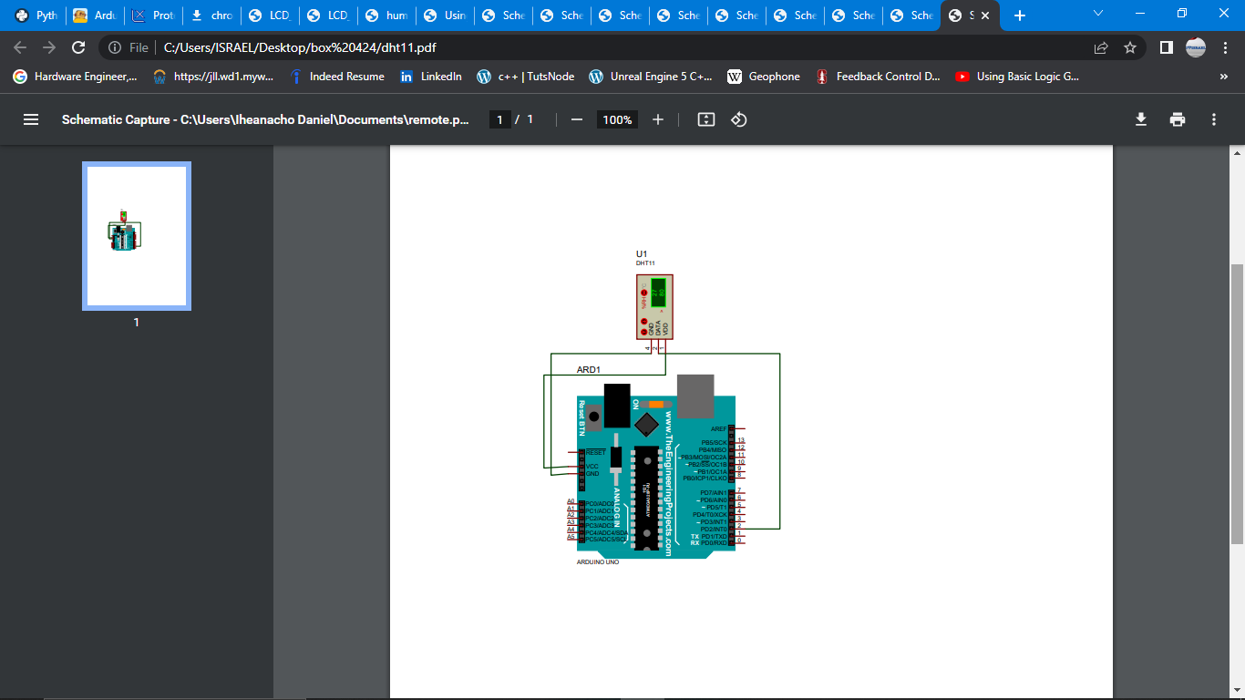

**BELOW ARE THE REQUIRED PROCEDURES**

make a Ground and 5 volts reel on the breadboard from the Arduino, so all connections to the ground or 5volts reel is still directly connected to the Arduino.

1. **Connecting the DHT11 to the Arduino**

* Connect the ground of the shift register to the Arduino ground Pin
* Connect the Vcc pin of the shift register to the Arduino 5v Pin
* Connect data Pin to pin 10

1. **Connecting the LCD to the Arduino**

* Connect the vdd of the ultra-sonic sensor to the Arduino ground Pin
* Connect the Vcc pin of the ultra-sonic sensor to the Arduino 5v Pin
* Connect the rs,en,d4,d5,d6,d7 pins to the assigned Arduino Pin.
* Connect VEE to potentiometer and potentiometer to ground and 5v according to the schematics
* Connect the blcka pin to ground and blckb pin to 5v.

Upload the code below

**CODE**



1. **DHT11 AND LCD FOR A PROTABLE TEMPERATURE AND HUMIDITY SENSOR**

Using DHT11 sensor to check for temperature humidity of the environment and LCD to print the output or humidity and temperature making it portable.

**THE NEEDED APPARATUS ARE:**

* **ARDUINO UNO**
* **DHT11 sensor**
* **330 OHMS RESISTORS**
* **LCD module**
* **JUMPER WIRES**
* **BREADBOARD**

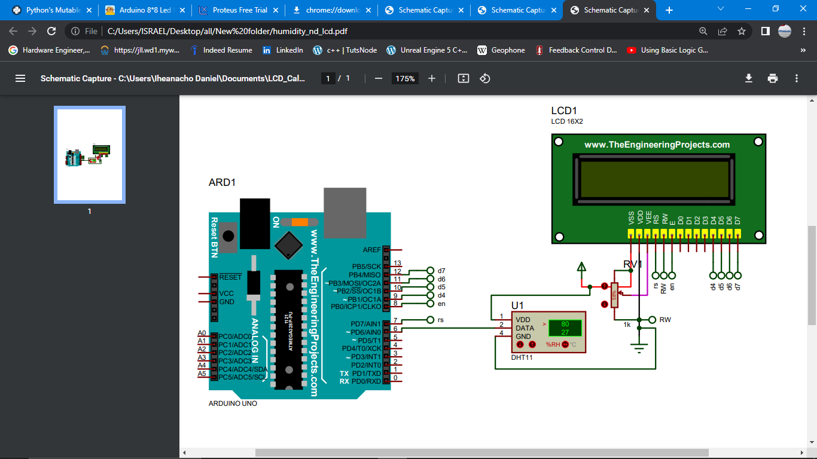

**BELOW ARE THE REQUIRED PROCEDURES**

make a Ground and 5 volts reel on the breadboard from the Arduino, so all connections to the ground or 5volts reel is still directly connected to the Arduino.

1. **Connecting the DHT11 to the Arduino**

* Connect the ground of the shift register to the Arduino ground Pin
* Connect the Vcc pin of the shift register to the Arduino 5v Pin
* Connect data Pin to pin 10

1. **Connecting the LCD to the Arduino**

* Connect the VDD of the ultra-sonic sensor to the Arduino ground Pin
* Connect the VCC pin of the ultra-sonic sensor to the Arduino 5v Pin
* Connect the rs,en,d4,d5,d6,d7 pins to the assigned Arduino Pin.
* Connect VEE to potentiometer and potentiometer to ground and 5v according to the schematics
* Connect the blcka pin to ground and blckb pin to 5v.

**CODE:**



1. **LED controlled motion detector bulb**

This is an automated LED using Pir motion sensor and DHT11 temperature and humidity sensor just to signify to the occupant if the temperature is comfortable or not using red LED with buzzer and green LED. This is done using the Arduino Uno. This is for walkways LED's.

**Note**: if the schematics breadboard was not used.

**THE NEEDED APPARATUS ARE:**

* **ARDUINO UNO**
* **PIR MOTION SENSOR**
* **WHITE, RED AND GREEN LEDS**
* **JUMPER WIRES**
* **330 OHMS RESISTORS X3**
* **BREADBOARD**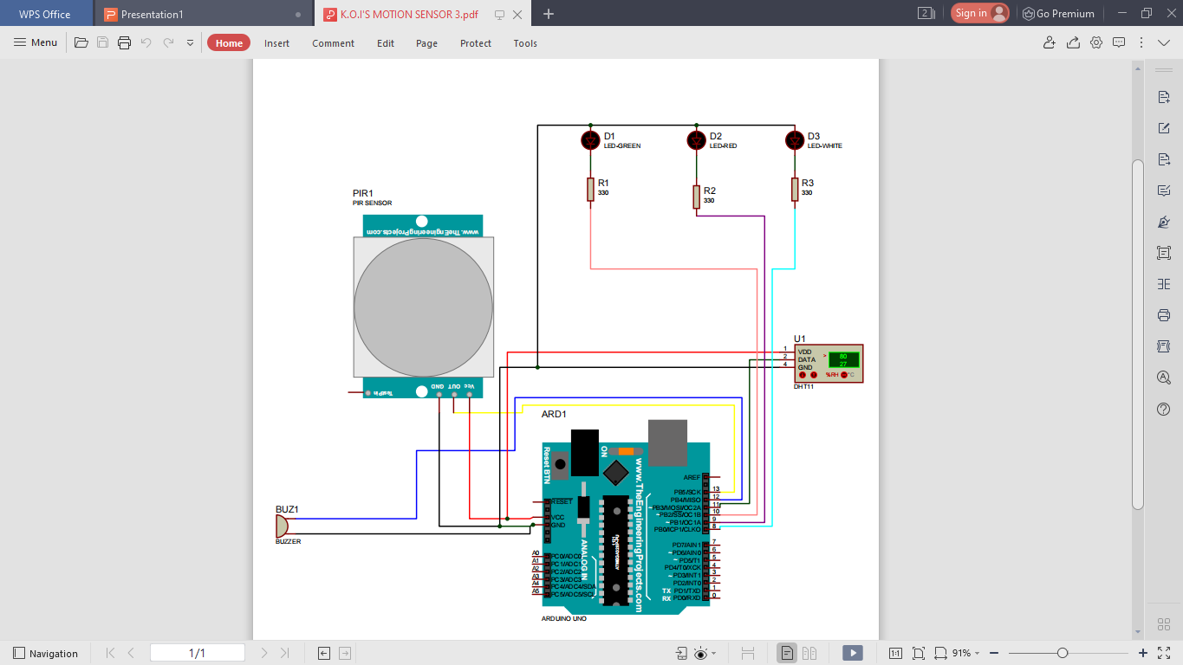

**BELOW ARE THE REQUIRED PROCEDURES**

make a Ground and 5 volts reel on the breadboard from the Arduino, so all connections to the ground or 5volts reel is still directly connected to the Arduino.

1. **Connecting Pir motion sensor to Arduino**

* Connect the ground pin of the Pir motion sensor to the Arduino ground pin
* Connect the Vcc pin of the Pir motion sensor to the Arduino 5v Pin
* Connect the Out pin of the Pir motion sensor to the Arduino Pin 13

1. **Connecting Buzzer to Arduino**

* Connect the short pin of the Buzzer to the ground of Arduino
* Connect the long Pin of the Buzzer to Arduino Pin 12

1. **Connecting the DHT11 sensor to the Arduino**

* Connect the ground pin of the DHT11 sensor to the Arduino ground Pin
* Connect the Vcc pin of the DHT11 sensor to the Arduino 5v Pin
* Connect the Out pin(Data Pin) of the DHT11sensor to the Arduino Pin 11

1. **Connecting LEDS to Arduino**

* Connect the ground pin(short Pin) of the LED to the Arduino ground Pin
* Connect the positive pin(long Pin) of the LED in series with a 330 Ohm resistor then to the Arduino Pins repectively.
* Green LED pin is Pin 10
* Red LED pin is Pin 9
* White LED pin is Pin 8
* Upload the code below

**CODE**

**This is the raw code attached**



The Motion sensor has a range and time delay that can be adjusted as shown below

Turn fully Anti-clockwise to reduce the time it takes before sensing next motion and

Turn fully clockwise to increase the range in which it senses motion

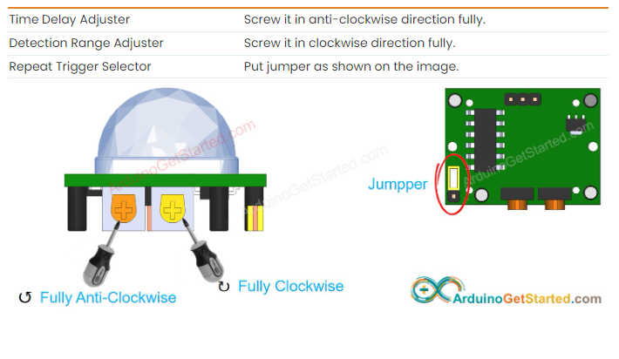

1. **ANTI-THEFT DETECTION SYSTEM USING MOTION DETECTOR**

This is an anti-theft using PIR motion sensor that prevent the access of anyone. So it is incorporated in back doors or inactive passages.

**THE NEEDED APPARATUS ARE:**

* **ARDUINO UNO**
* **PIR MOTION SENSOR**
* **JUMPER WIRES**
* **BUZZER(ACTIVE)**
* **330 OHMS RESISTORS X3**
* **BREADBOARD**

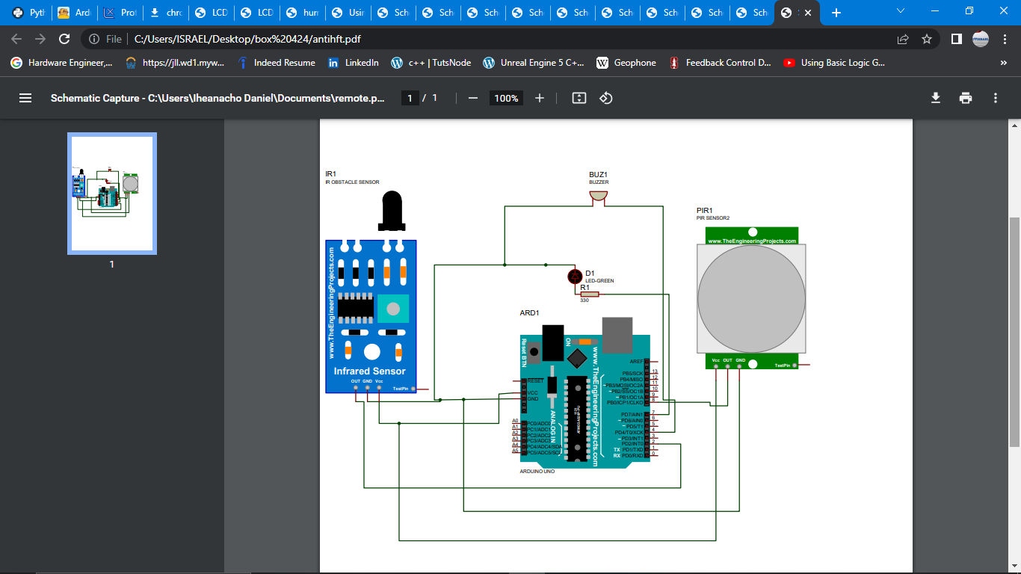

**BELOW ARE THE REQUIRED PROCEDURES**

make a Ground and 5 volts reel on the breadboard from the Arduino, so all connections to the ground or 5volts reel is still directly connected to the Arduino.

1. **Connecting PIR motion sensor to Arduino**

* Connect the ground pin of the PIR motion sensor to the Arduino ground pin
* Connect the Vcc pin of the PIR motion sensor to the Arduino 5v Pin
* Connect the Out pin of the PIR motion sensor to the Arduino Pin 13

1. **Connecting Buzzer to Arduino**

* Connect the short pin of the Buzzer to the ground of Arduino
* Connect the long Pin of the Buzzer to Arduino Pin 12

**CODE:**



1. **RFID SECURITY PASS**

Using the RFID module to sense RFID chips comparing their unique ID to see if it is recognized.

**THE NEEDED APPARATUS ARE:**

* **ARDUINO UNO**
* **RFID MODULE**
* **JUMPER WIRES**
* **BUZZER(ACTIVE)**
* **LEDS RED AND GREEN**
* **330 OHMS RESISTORS X3**
* **BREADBOARD**

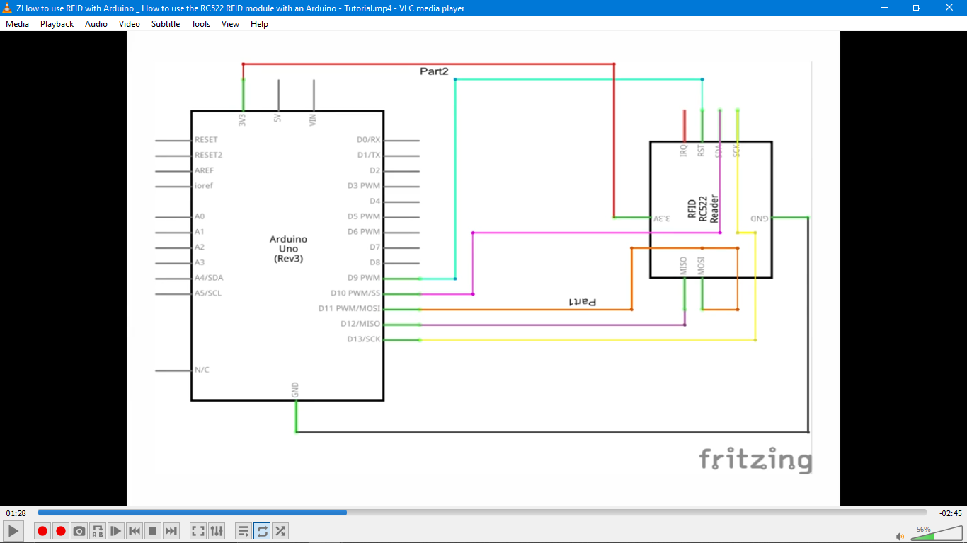

**BELOW ARE THE REQUIRED PROCEDURES**

make a Ground and 5 volts reel on the breadboard from the Arduino, so all connections to the ground or 5volts reel is still directly connected to the Arduino.

1. **Connecting LEDS to Arduino**

* Connect the ground pin(short Pin) of the LED to the Arduino ground Pin
* Connect the positive pin(long Pin) of the LED in series with a 330 Ohm resistor then to the Arduino Pins repectively.
* Connect the pins of the LEDS to the Arduino pin from the other end of the resistor.

1. **Connecting RFID module to Arduino**

* Connect the ground pin of the RFID to the Arduino ground pin
* Connect the Vcc pin of the Pir motion sensor to the Arduino 3.3v Pin
* Connect the all data pins as shown in the schematics

1. **Connecting Buzzer to Arduino**

* Connect the short pin of the Buzzer to the ground of Arduino
* Connect the long Pin of the Buzzer to Arduino Pin 12
* Upload the code below

**CODE:**



1. **RFID USING THE REAL TIME CLOCK MODULE ATTENDANCE SYSTEM**

Using the RFID module to sense RFID chips comparing their unique ID to see if it is recognized.

**THE NEEDED APPARATUS ARE:**

* **ARDUINO UNO**
* **RFID MODULE**
* **JUMPER WIRES**
* **RTC MODULE**
* **LEDS RED AND GREEN**
* **330 OHMS RESISTORS X3**
* **BREADBOARD**



**BELOW ARE THE REQUIRED PROCEDURES**

1. make a Ground and 5 volts reel on the breadboard from the Arduino, so all connections to the ground or 5volts reel is still directly connected to the Arduino.
2. **Connecting LEDS to Arduino**

* Connect the ground pin(short Pin) of the LED to the Arduino ground Pin
* Connect the positive pin(long Pin) of the LED in series with a 330 Ohm resistor then to the Arduino Pins repectively.
* Connect the pins of the LEDS to the Arduino pin from the other end of the resistor.

1. **Connecting RFID module to Arduino**

* Connect the ground pin of the RFID to the Arduino ground pin
* Connect the Vcc pin of the Pir motion sensor to the Arduino 3.3v Pin

Connect the all data pins as shown in the schematics

1. **Connecting the RTC(real time clock) module to the Arduino**

* Connect the ground pin of the RTC to the Arduino ground Pin
* Connect the Vcc pin of the RTC to the Arduino 5v or 3.3v Pin
* Connect the SCL and SDA pins to the assigned Arduino Pin.

Upload the code below

**CODE**



1. **CONTROLLED SERVO MOTOR FOR LIGHT DETECTION**

This is just a simulation showing Sunset Sunrise and Sundown.

**THE NEEDED APPARATUS ARE:**

* **ARDUINO UNO**
* **PHOTO RESISTOR**
* **SERVO MOTOR**
* **JUMPER WIRES**
* **BREADBOARD**

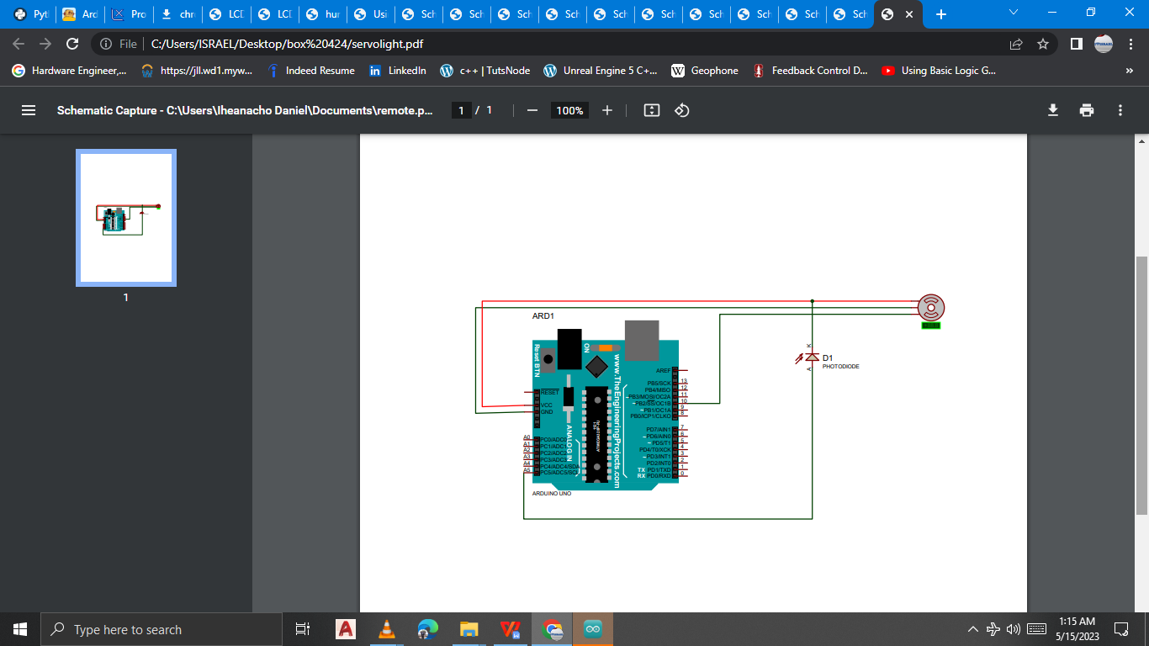

**BELOW ARE THE REQUIRED PROCEDURES**

make a Ground and 5 volts reel on the breadboard from the Arduino, so all connections to the ground or 5volts reel is still directly connected to the Arduino.

1. **Connecting servo motor to Arduino**

* Connect the ground pin of the servo motor to the Arduino ground pin
* Connect the Vcc pin of the servo motor to the Arduino 3.3v Pin
* Connect the Out pin of the servo motor to the Arduino specified pin

1. **Connecting Photo-resistor to Arduino**

* Connect one pin of the Photo-resistor to 5v of Arduino
* Connect the other Pin of the Photo-resistor Arduino Pin specified.
* Upload the code below

**CODE**



1. **REMOTE CONTROLLED STEPPER MOTOR**

This is the use of IR remote to control stepper motor direction and speed

**THE NEEDED APPARATUS ARE:**

* **ARDUINO UNO**
* **IR RECEIVER AND IR REMOTE**
* **STEPPER MOTOR**
* **JUMPER WIRES**
* **EXTERNAL POWER DC SUPPLY 5V- -9V**
* **BREADBOARD**

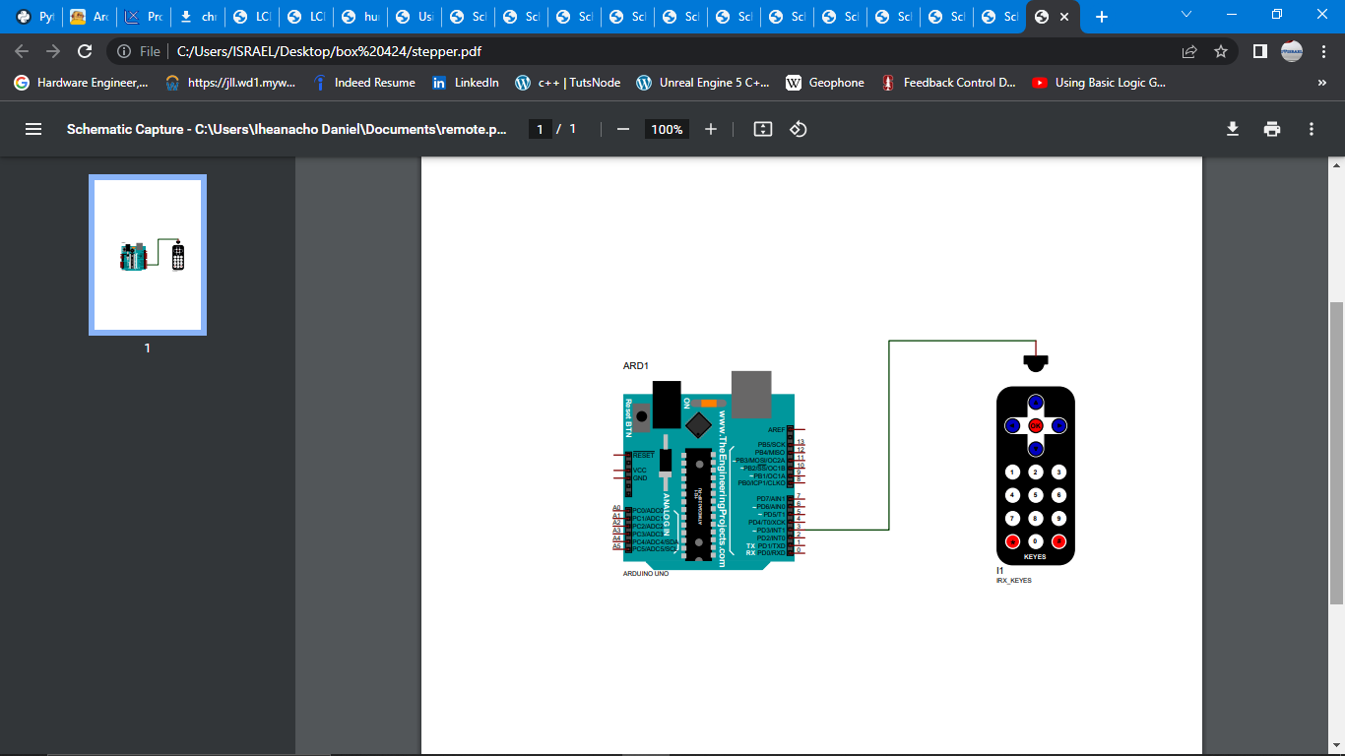

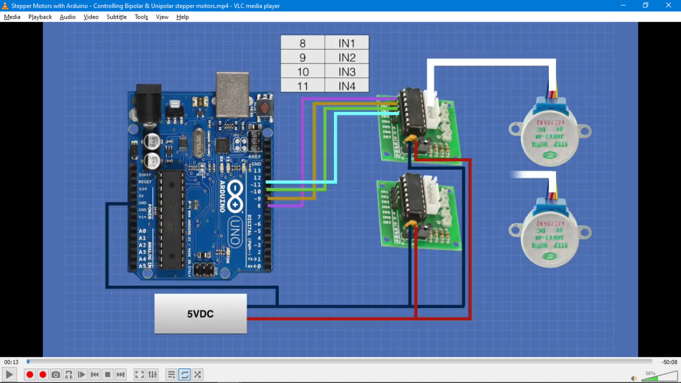

**BELOW ARE THE REQUIRED PROCEDURES**

1. make a Ground and 5 volts reel on the breadboard from the Arduino, so all connections to the ground or 5volts reel is still directly connected to the Arduino.
2. **Connecting stepper motor to Arduino**

**NOTE:** the stepper motor cannot be powered on through the Arduino so we need an external power supply

* Connect the stepper motor to its driver IC
* Connect the ground pin of the IC to the external power supply and to the ground of the Arduino
* Connect the VCC pin of the servo motor to the external power supply positive pin
* Connect the input pins of the IC to the Arduino as indicated in the schematics
* Photo-resistor Arduino Pin specified.

1. **Connecting the IR receiver to the Arduino**

* Connect the ground of the shift register to the Arduino ground Pin
* Connect the Vcc pin of the shift register to the Arduino 5v Pin
* Connect IR pin to specified Arduino Pin
* Upload the code below



1. **USING THE OV7670 CAMERA MODULE TO TAKE PICTURES**

**Note:** This was largely down by other Arduino programmers(Circuit digest) and was copied.

**THE NEEDED APPARATUS ARE:**

* **ARDUINO UNO**
* **OV7670 CAMERA MODULE**
* **RESISTORS(10K, 4.7K)**
* **JUMPERS**
* **SERIAL PLOTTER READER**

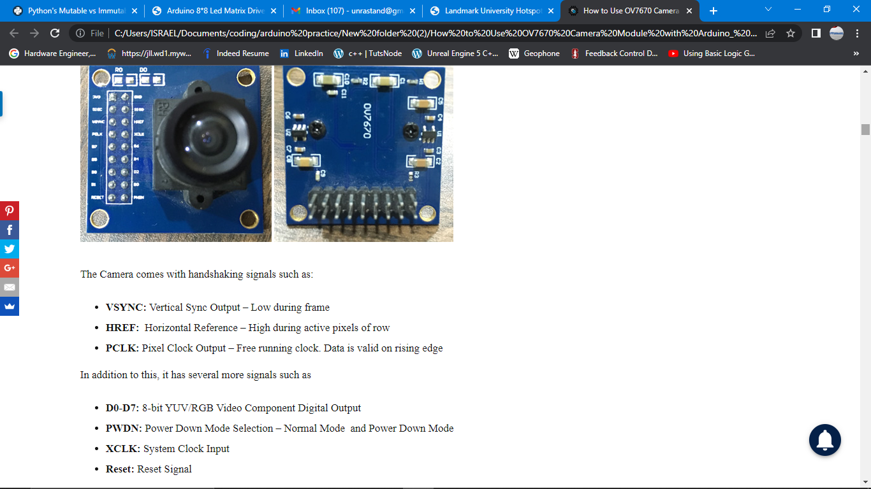

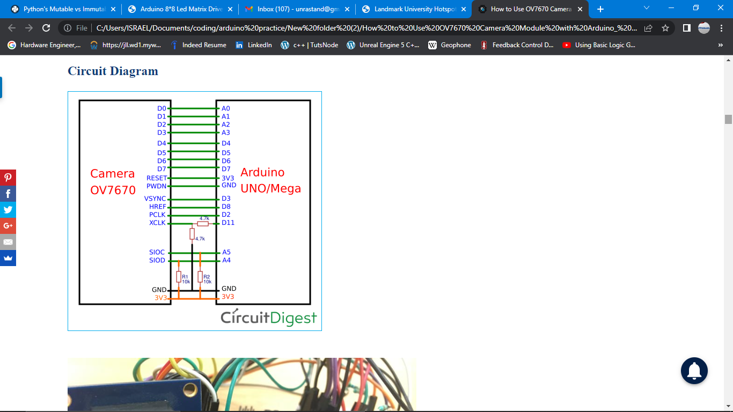



1. **Sound controlled LED**

Using the microphone sound sensor to detect sound and use the data to control LED.

**THE NEEDED APPARATUS ARE:**

* **ARDUINO UNO**
* **LED**
* **MICROPHONE SOUND SENSOR**
* **330 OHM RESISTOR**

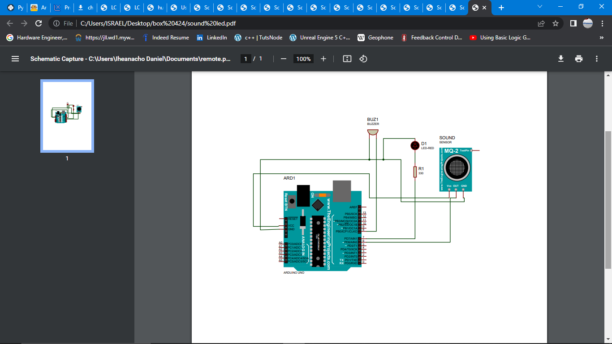

**BELOW ARE THE REQUIRED PROCEDURES**

1. make a Ground and 5 volts reel on the breadboard from the Arduino, so all connections to the ground or 5volts reel is still directly connected to the Arduino.
2. **Connecting Sound sensor to Arduino**

* Connect the ground pin of the Pir motion sensor to the Arduino ground pin
* Connect the Vcc pin of the Pir motion sensor to the Arduino 5v Pin
* Connect the Out pin of the Pir motion sensor to the Arduino specified Pin

1. **Connecting LED to Arduino**

* Connect the ground pin(short Pin) of the LED to the Arduino ground Pin
* Connect the positive pin(long Pin) of the LED in series with a 330 Ohm resistor then to the Arduino Pins repectively.
* LED pin is Pin specified.
* Upload the code below

**CODE**



1. **Sound regulator warning system**

Using sound sensor and buzzer with red led, senses high sound if dangerous alarms.

Using the microphone sound sensor to detect sound and use the data to control LED.

**THE NEEDED APPARATUS ARE:**

* **ARDUINO UNO**
* **LED**
* **BUZZER**
* **MICROPHONE SOUND SENSOR**
* **330 OHM RESISTOR**

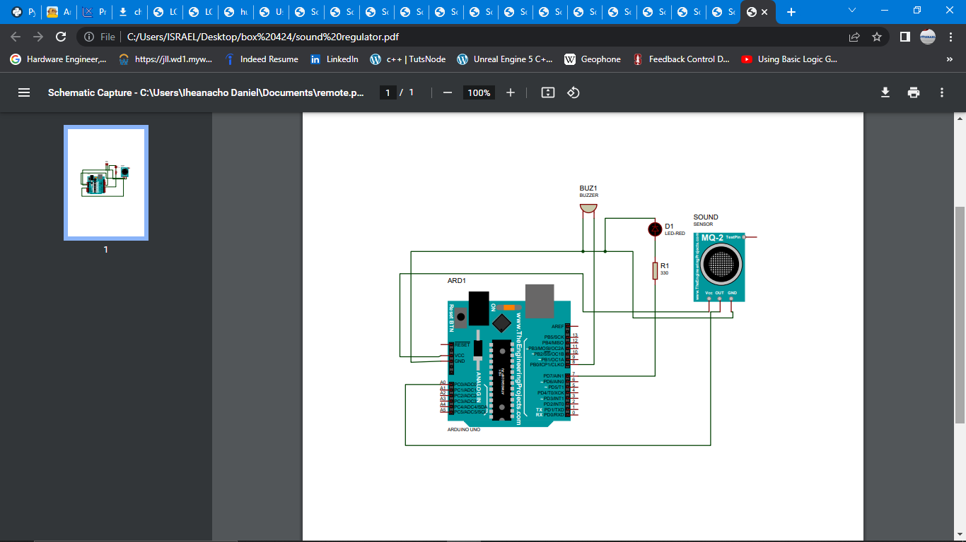

**BELOW ARE THE REQUIRED PROCEDURES**

1. make a Ground and 5 volts reel on the breadboard from the Arduino, so all connections to the ground or 5volts reel is still directly connected to the Arduino.
2. **Connecting Sound sensor to Arduino**

* Connect the ground pin of the PIR motion sensor to the Arduino ground pin
* Connect the Vcc pin of the PIR motion sensor to the Arduino 5v Pin
* Connect the Out pin of the PIR motion sensor to the Arduino specified Pin

1. **Connecting LED to Arduino**

* Connect the ground pin(short Pin) of the LED to the Arduino ground Pin
* Connect the positive pin(long Pin) of the LED in series with a 330 Ohm resistor then to the Arduino Pins repectively.
* LED pin is Pin specified.

1. **Connecting Buzzer to Arduino**

* Connect the short pin of the Buzzer to the ground of Arduino
* Connect the long Pin of the Buzzer to Arduino Pin 12
* Upload the code below



1. **TILT SENSOR AS SAFETY MEASURE FOR DEVICES**

Stops devices if be turned over and cannot be use for vibrating devices.

**THE NEEDED APPARATUS ARE:**

* **ARDUINO UNO**
* **LED**
* **BUZZER**
* **TILT SENSOR**
* **330 OHM RESISTOR**

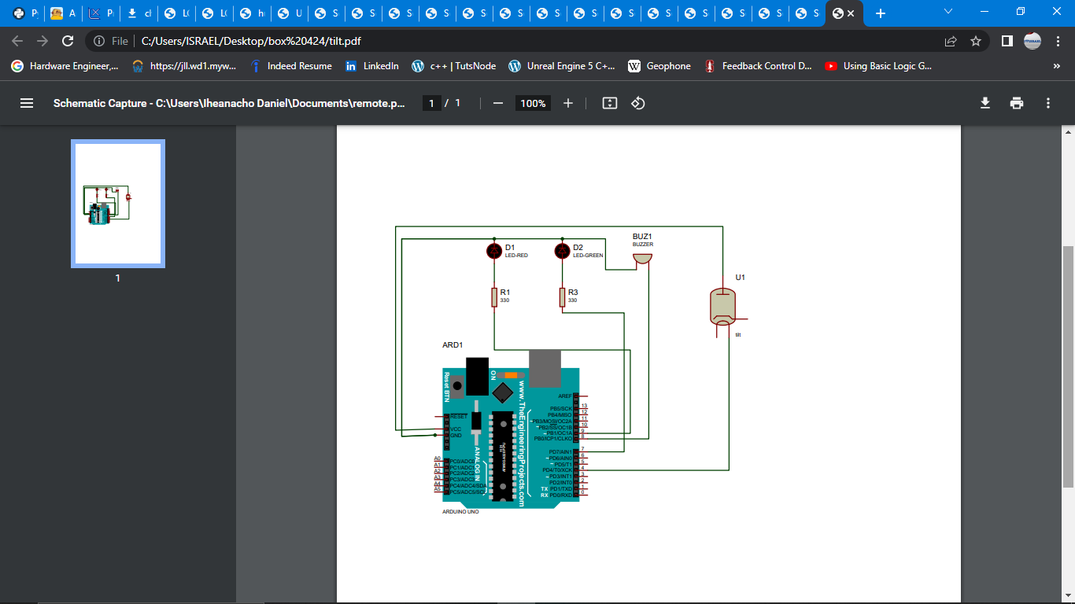

**BELOW ARE THE REQUIRED PROCEDURES**

1. make a Ground and 5 volts reel on the breadboard from the Arduino, so all connections to the ground or 5volts reel is still directly connected to the Arduino.
2. **Connecting Tilt sensor to Arduino**

* Connect the 5v pin to one pin of the sensor
* Connect the other pin of the sensor to the Arduino specified Pin

1. **Connecting LED to Arduino**

* Connect the ground pin(short Pin) of the LED to the Arduino ground Pin
* Connect the positive pin(long Pin) of the LED in series with a 330 Ohm resistor then to the Arduino Pins repectively.
* LED pin is Pin specified.

1. **Connecting Buzzer to Arduino**

* Connect the short pin of the Buzzer to the ground of Arduino
* Connect the long Pin of the Buzzer to Arduino Pin specified
* Upload the code below



1. **BLUETOOTH CONTROLLED LEDS,BUZZERS**

Using the Bluetooth module HC-05 to interface between Arduino and a Bluetooth device(phone) to control LEDs.

**THE NEEDED APPARATUS ARE:**

* **ARDUINO UNO**
* **HC-05 BLUETOOTH MODULE**
* **LEDS**
* **BUZZER**
* **330 OHM RESISTOR**
* **JUMPER WIRES**
* **BREADBOARD**

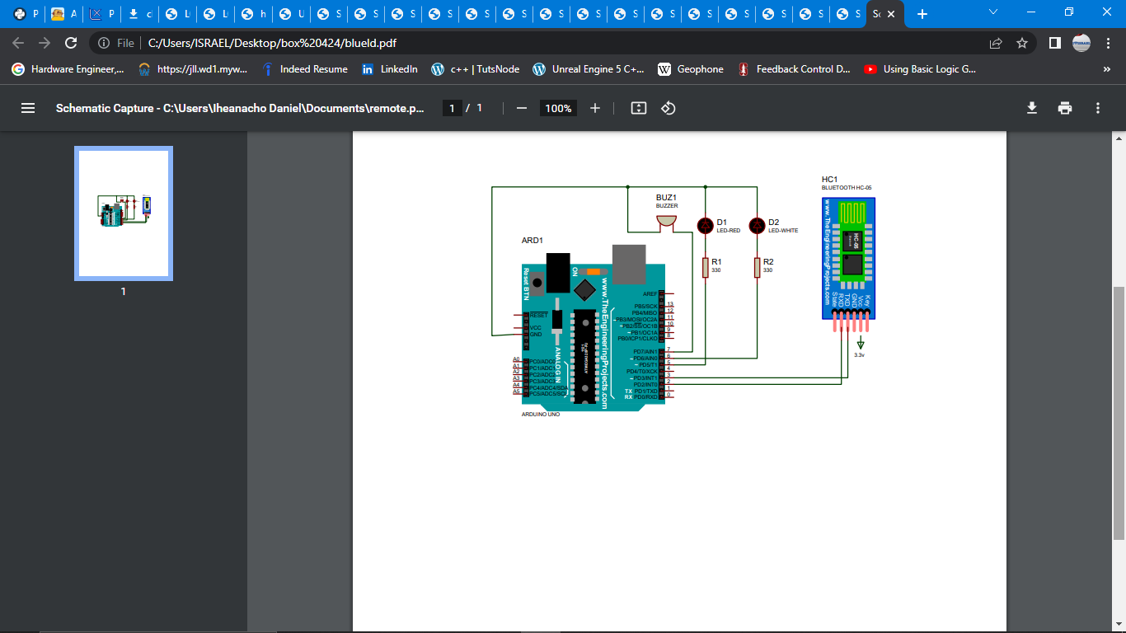

**BELOW ARE THE REQUIRED PROCEDURES**

1. make a Ground and 5 volts reel on the breadboard from the Arduino, so all connections to the ground or 5volts reel is still directly connected to the Arduino.
2. **Connecting the Bluetooth to the Arduino**

* Connect the ground of the shift register to the Arduino ground Pin
* Connect the Vcc pin of the shift register to the Arduino 3,3v Pin
* Connect TX pin specified
* Connect the Rx to pin specified

1. **Connecting LEDS to Arduino**

* Connect the ground pin(short Pin) of the LED to the Arduino ground Pin
* Connect the positive pin(long Pin) of the LED in series with a 330 Ohm resistor then to the Arduino Pins repectively.

1. **Connecting Buzzer to Arduino**

* Connect the short pin of the Buzzer to the ground of Arduino
* Connect the long Pin of the Buzzer to Arduino Pin specified.

Upload the code below



1. **WATER LEVEL DETECTION**

Using the water level sensor to sense water level.

**THE NEEDED APPARATUS ARE:**

* **ARDUINO UNO**
* **WATER LEVEL SENSOR**
* **LEDS**
* **BUZZER**
* **JUMPER WIRES**
* **330 OHMS RESISTORS X3**
* **BREADBOARD**

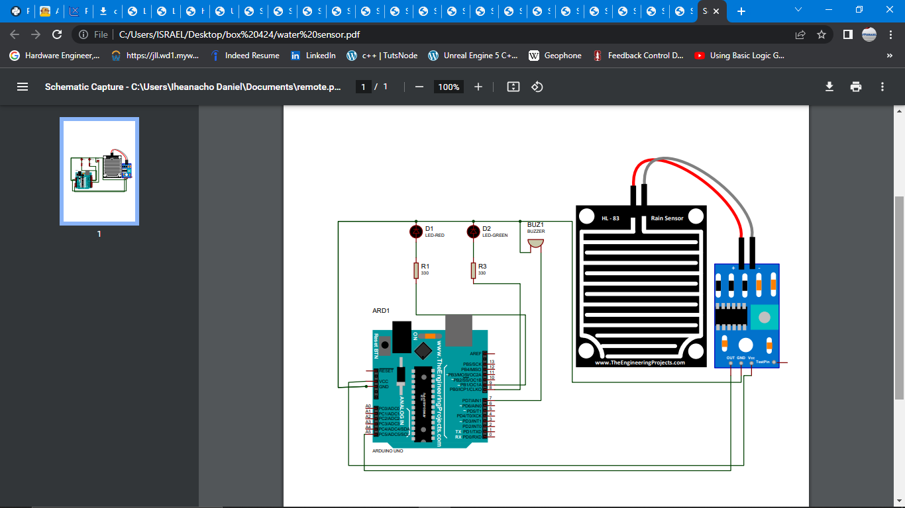

**BELOW ARE THE REQUIRED PROCEDURES**

1. make a Ground and 5 volts reel on the breadboard from the Arduino, so all connections to the ground or 5volts reel is still directly connected to the Arduino.
2. **Connecting Buzzer to Arduino**

* Connect the short pin of the Buzzer to the ground of Arduino
* Connect the long Pin of the Buzzer to Arduino Pin 12

1. **Connecting the water level sensor to the Arduino**

* Connect the ground pin of the sensor to the Arduino ground Pin
* Connect the Vcc pin of the sensor to the Arduino 5v Pin
* Connect the Out pin(Data Pin) of the DHT11sensor to the Arduino Pin Specified.

1. **Connecting LEDS to Arduino**

* Connect the ground pin(short Pin) of the LED to the Arduino ground Pin
* Connect the positive pin(long Pin) of the LED in series with a 330 Ohm resistor then to the Arduino Pins repectively.
* Upload the code below



1. **PASSWORD SYSTEM USING KEYPAD MODULE**

Using the keypad module to input passwords that can be compared to a set password.

**THE NEEDED APPARATUS ARE:**

* **ARDUINO UNO**
* **KEYPAD MODULE**
* **JUMPER WIRES**
* **BREADBOARD**

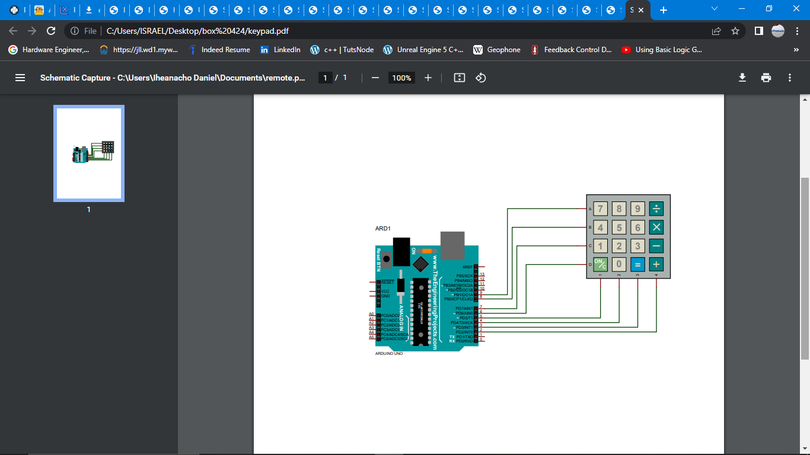

**BELOW ARE THE REQUIRED PROCEDURES**

1. make a Ground and 5 volts reel on the breadboard from the Arduino, so all connections to the ground or 5volts reel is still directly connected to the Arduino.
2. **Connecting the keypad module to the Arduino**

* Connect the ground pin of the module to the Arduino ground Pin
* Connect the Vcc pin of the module to the Arduino 5v Pin
* Connect the Data Pin of the module to the Arduino Pin specified
* Upload the code below

**CODE**



1. **DIMMABLE TACT SWITCH LED BULB**

Using tact switch to dim and increase the brightness or LED

**THE NEEDED APPARATUS ARE:**

* **ARDUINO UNO**
* **TACT SWITCH X2**
* **LEDS**
* **JUMPER WIRES**
* **330 OHMS RESISTORS**
* **BREADBOARD**

**BELOW ARE THE REQUIRED PROCEDURES**

1. make a Ground and 5 volts reel on the breadboard from the Arduino, so all connections to the ground or 5volts reel is still directly connected to the Arduino.

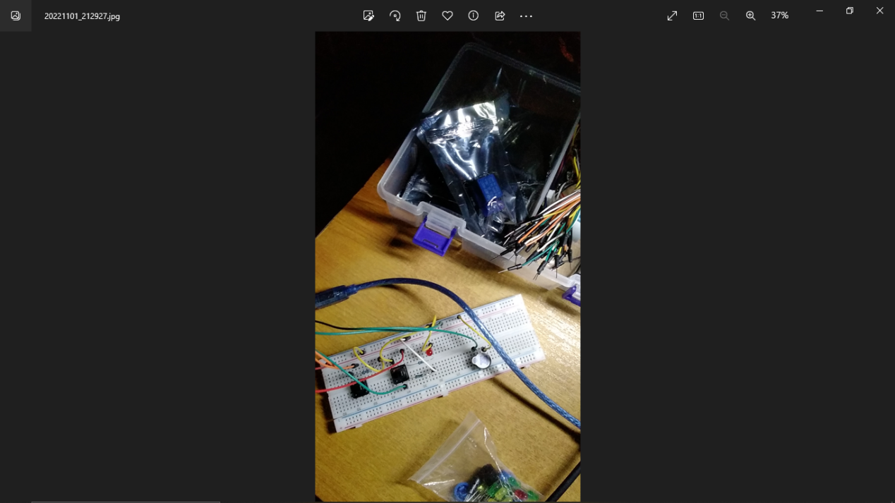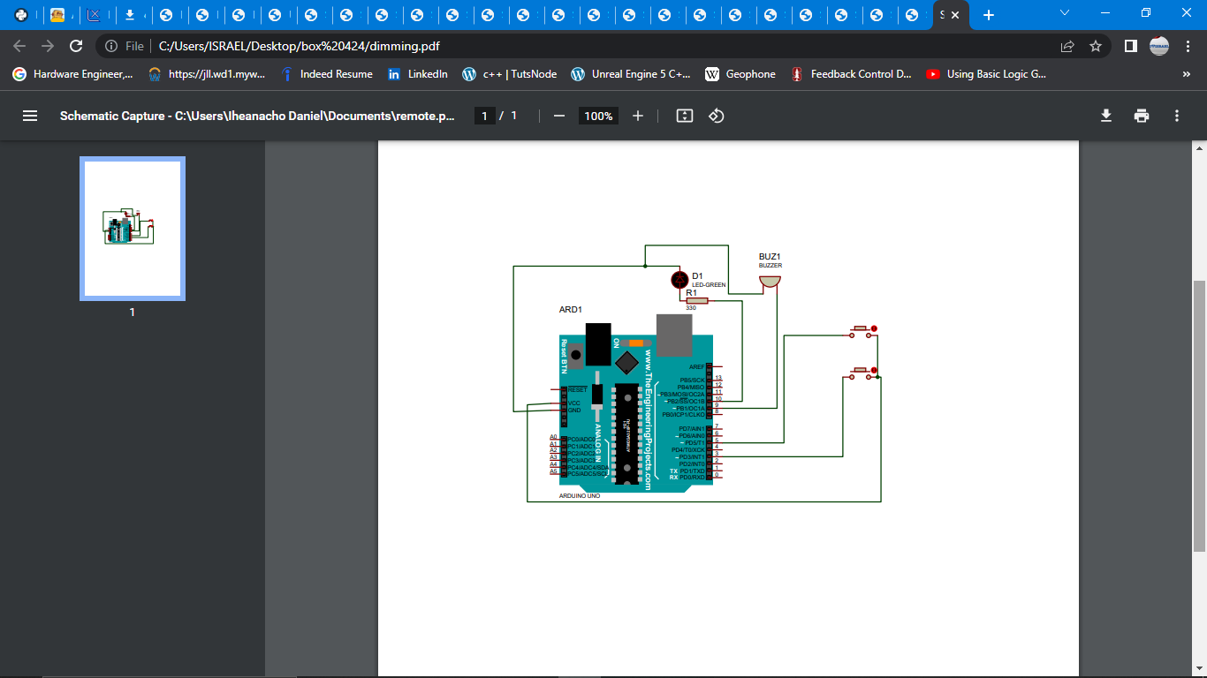

1. **Connecting tact switch to Arduino**

* Connect one pin of the switch to the Arduino 5v pin
* Connect the other pin of the switch to the Arduino Pin specified

1. **Connecting Buzzer to Arduino**

* Connect the short pin of the Buzzer to the ground of Arduino
* Connect the long Pin of the Buzzer to Arduino Pin 12

1. **Connecting the DHT11 sensor to the Arduino**

* Connect the ground pin of the DHT11 sensor to the Arduino ground Pin
* Connect the Vcc pin of the DHT11 sensor to the Arduino 5v Pin
* Connect the Out pin(Data Pin) of the DHT11sensor to the Arduino Pin 11

1. **Connecting LEDS to Arduino**

* Connect the ground pin(short Pin) of the LED to the Arduino ground Pin
* Connect the positive pin(long Pin) of the LED in series with a 330 Ohm resistor then to the Arduino Pins repectively.
* Green LED pin is Pin 10
* Red LED pin is Pin 9
* White LED pin is Pin 8
* Upload the code below

**CODE**



1. **AUTOMATIC NIGHT LED USING PHOTO-RESISTOR**

**THE NEEDED APPARATUS ARE:**

* **ARDUINO UNO**
* **LED**
* **PHOTORESISTOR**
* **JUMPER WIRES**
* **BUZZER**
* **330 OHMS RESISTORS**
* **BREADBOARD**

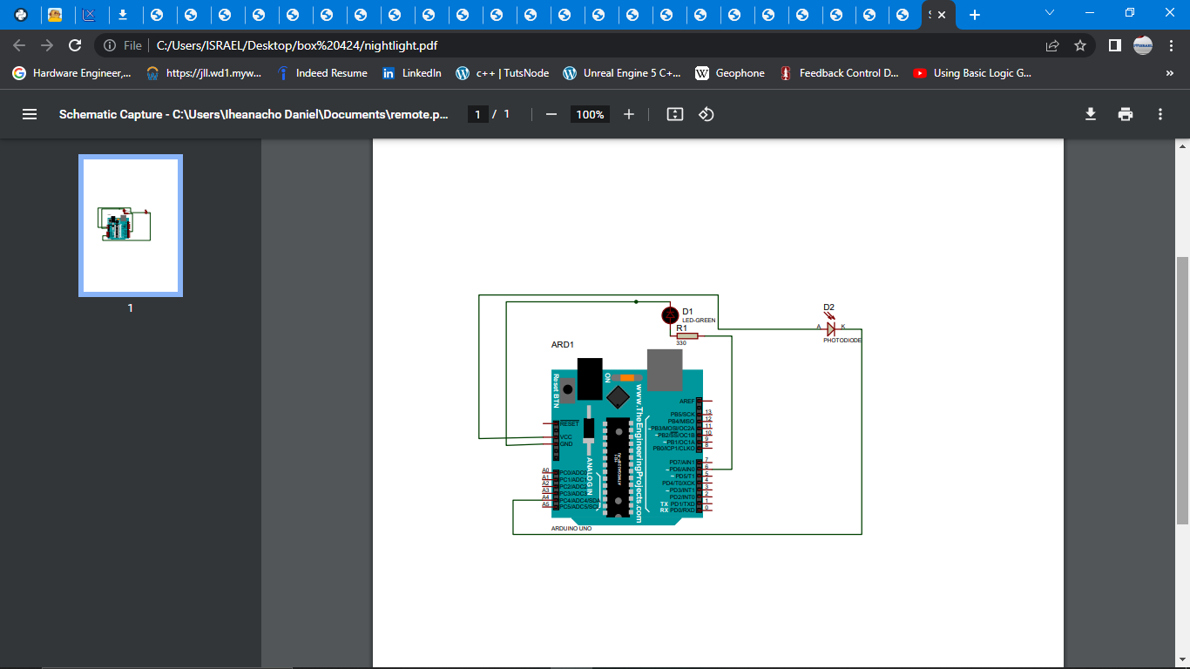

**BELOW ARE THE REQUIRED PROCEDURES**

1. make a Ground and 5 volts reel on the breadboard from the Arduino, so all connections to the ground or 5volts reel is still directly connected to the Arduino.
2. **Connecting Photo-resistor to Arduino**

* Connect one pin of the Photo-resistor to 5v of Arduino
* Connect the other Pin of the Photo-resistor Arduino Pin specified.

1. **Connecting Buzzer to Arduino**

* Connect the short pin of the Buzzer to the ground of Arduino
* Connect the long Pin of the Buzzer to Arduino Pin Specified

**Connecting LEDS to Arduino**

* Connect the ground pin(short Pin) of the LED to the Arduino ground Pin
* Connect the positive pin(long Pin) of the LED in series with a 330 Ohm resistor then to the Arduino Pins repectively.
* Upload the code below

**CODE**



**THANKS TO GOD ALMIGHTY ESPECIALLY, PAUL WORTHER MY FIRST ARDUINO TEACHER WHO HELP ME, ANGELA YUU AND SEVERAL OTHERS.**